Appendix B
(Normative Appendix)
Steel grating gutter cover

Steel grating gutter cover is used as a cover for water ditch, pipeline ditch, underground passage, ventilation shaft, daylighting shaft, inspection shaft, etc. on the ground of sidewalk, roadway, yard or building.
Steel grating gutter covers are typically composed of a fixed frame and a movable steel grating cover. They can be equipped with fastening mechanisms or anti-theft devices as required.
place 。

B.1 GT Type Standard Side and Cross-Sectional Steel Grating Grating Cover
Road drainage grating covers are classified into side grating covers and transverse grating covers based on the direction of vehicle traffic. The flat steel plates perpendicular to the traffic direction are called side grating covers, while those parallel to the traffic direction are termed transverse grating covers.

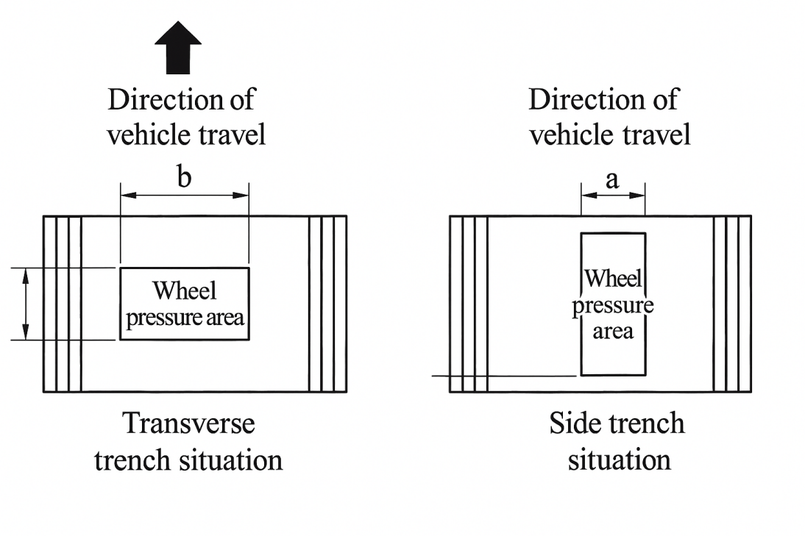

B.1.1 GT-type steel grating gutter covers are suitable for road applications other than highways, typically with low traffic volume. When used as cross-gutter covers, the risk of cover plate lifting must be considered, requiring bolted fastening. All GT-type steel grating gutter covers are treated with hot-dip galvanizing for corrosion resistance. See Figure B.2 for the GT-type steel grating gutter cover.

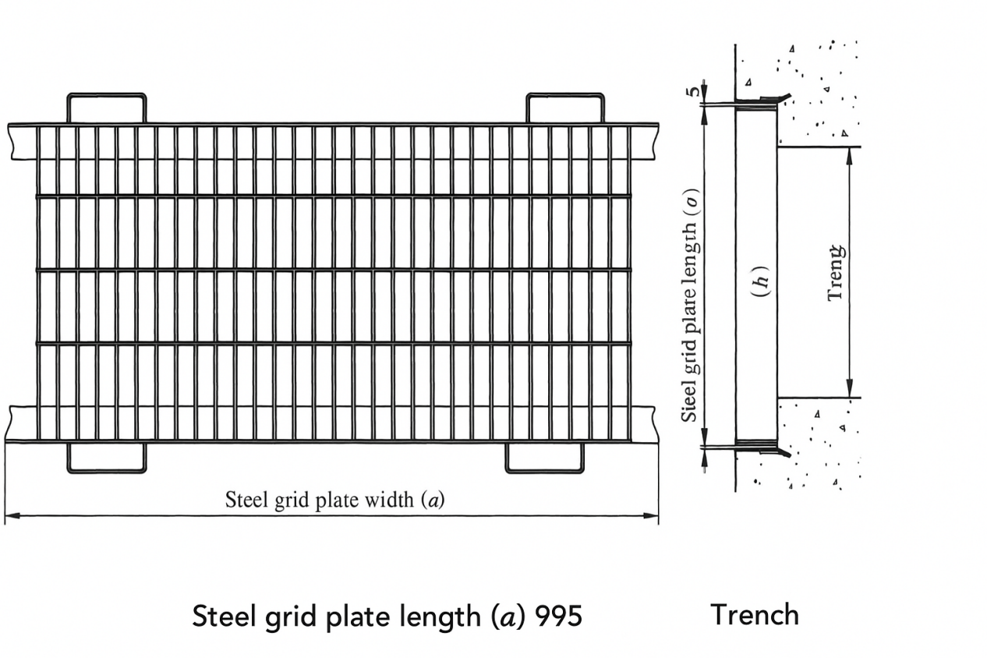
B.1.2 GT steel grating gutter covers are designed for use on gutter edges with T-shaped supports, where the edges are typically constructed with angle steel.B.1.3 The T-2, T-6, T-14, T-20, T-25, etc. in Table B.2 indicate that vehicles with total allowable weights of 2000kg, 6000kg, 14000kg, 20000kg, 25000kg, etc. are allowed to pass.
B.1.4 The standard steel grating specification is typically G×××/30/100, though other models may be used. For public space grating covers, models with 50mm horizontal bar spacing are recommended. The use of toothed flat steel or I-shaped steel grating covers shall be mutually agreed upon by both parties. B.1.4 The standard steel grating specification is typically G×××/30/100, though other models may be used. For public space grating covers, models with 50mm horizontal bar spacing are recommended. The use of toothed flat steel or I-shaped steel grating covers shall be mutually agreed upon by both parties.
B.1.5 The standard side and cross ditch steel grating covers for GT-type are shown in Table B.2. Model specifications:

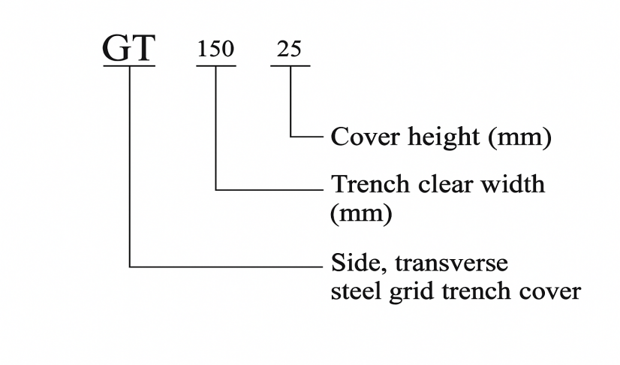

B.2 GU-type groove steel grating cover
The GU-type groove steel grating cover is shown in Figure B.3.

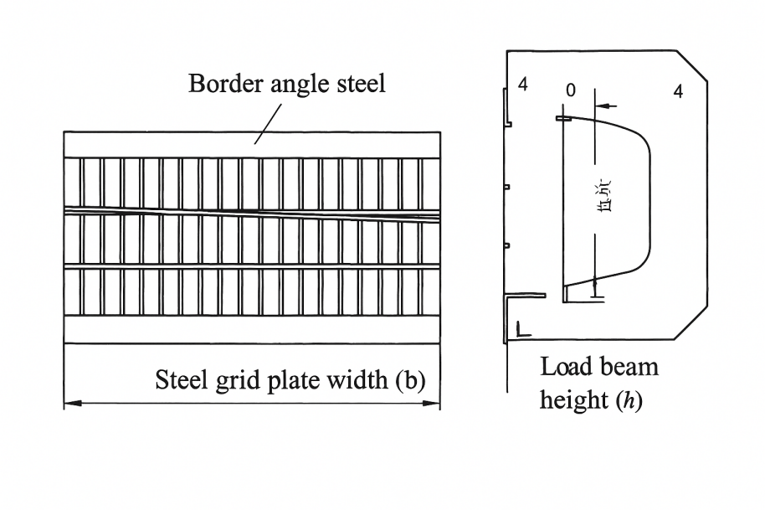
B.2.1 For most ordinary concrete-built gutters without side openings, using U-shaped cover plates is simple and cost-effective, eliminating the need for special side openings. When handling loads T-6 and T-14, it is recommended to embed angle steel at the upper edge of the gutter. Alternatively, prefabricated U-shaped gutter blocks can be used to construct the water channel, effectively preventing sewage leakage into the ground. These prefabricated U-shaped gutters can also be fitted with the same type of cover plates.
B.2.2 When vehicle passage is required, the GU-type grate cover plate is exclusively applicable to side drains.
B.2.3 The specifications and loadings of the steel grating are shown in Table B.3. Model description:

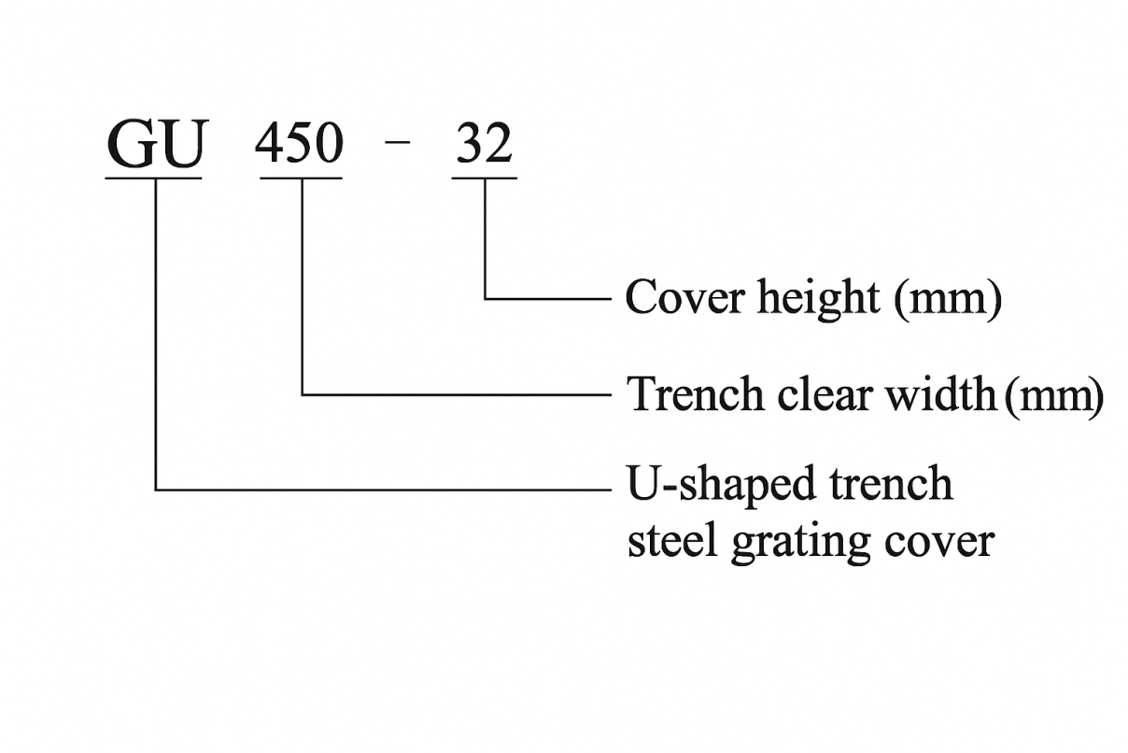

B.3 GM type well hole steel grating cover
The GM-type well hole steel grating cover is shown in Figure B.4.
B.3.1 GM-type steel grating covers are applicable to manholes of municipal facilities such as roads, industrial parks, and other infrastructure, including rainwater wells, sedimentation wells, sewer wells, and sewage wells. These covers are typically designed as flip-top models with a standard opening angle of 110°. The hinged steel grating covers not only provide theft resistance but also simplify construction procedures.

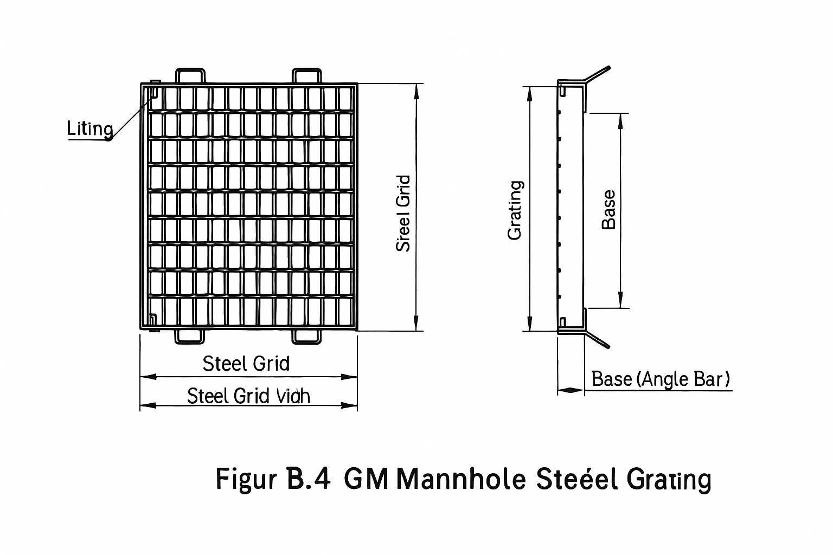

B.3.2 To enhance impact resistance, GM-type wellhole steel grating covers are typically manufactured with grating bars spaced 50mm apart.
B.3.3 The steel grating covers for the well holes specified in Table B.4 can all be used as cross ditch covers. Model description:

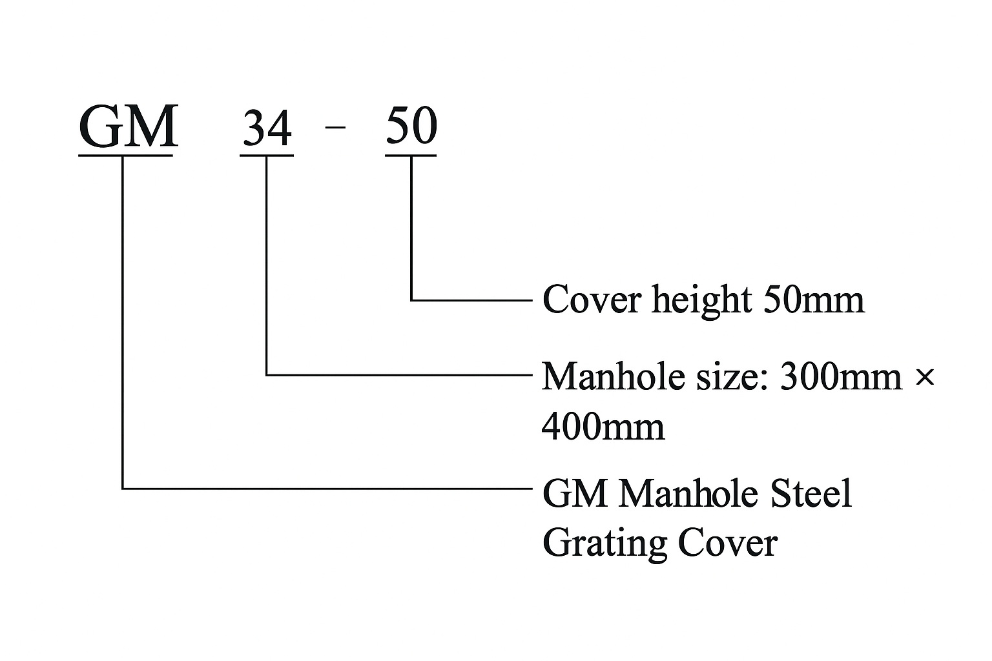

B.4 Load class of culvert cover
The load grade of the roadway steel grating gutter cover is shown in Table B.1.
Table B.1 Lane ditch cover load grade

Load level | Full load mass  kg | Post-load  kN | Rolling area a×b mm²
T-25 | 25000 | 100 | 200×500
T-20 | 20000 | 80 | 200×500
T-14 | 14000 | 56 | 200×500
T-6 | 6000 | 24 | 200×240
T-2 | 2000 | 8 | 200×160

B.5 Design calculation of steel grating gutter cover
The fundamental approach to calculating the load of a steel grating gutter cover is to use the bending moment at its midpoint as the maximum load, with the calculation process taking into account
The wheel load is evenly distributed across the bearing flat steel based on the ground contact area of each wheel. When the bending stress on each bearing flat steel does not exceed the material's strength design value, it is deemed to meet the strength requirements. Additionally, the maximum deflection must be calculated. For roadway gutter covers, the deflection should not exceed 1/500 of the span.
B.5.1 Strength Calculation
The wheel load can be simplified to the model shown in Figure B.5.

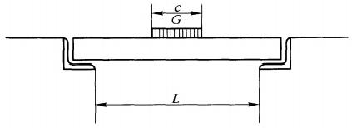

Figure B.5 Wheel load model

cause ：

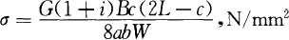
reach ：

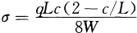

………………………………………(B.1)

……………………………(B.2)

For transverse ditch covers, i is set to 0.4; for side ditch covers, i is 0. When c≥L, c is set to L.
In Figure B.5, Equation B.1, and Equation B.2:
c —— the rear wheel landing width in the span direction, measured in millimeters (mm); L —— the support distance (span), measured in millimeters (mm);
G — rear wheel load, N;
B — Center-to-center spacing of flat steel, measured in millimeters (mm);
i—— impact coefficient ；
W —— the resistance moment of the flat steel section, measured in cubic millimeters (mm³); ab —— the wheel pressure area, measured in square millimeters (mm²).

B.5.2 Deflection Calculation

in the formula:
q=GB/ab;
E —— Elastic modulus of steel, E=206×10³N/mm²; I —— Inertia moment of section, for flat steel I=bt³/12.

YB/T 4001.1—2007
Table B.2: Steel Grating Cover for GT Type Side and Cross Grooves

furrow width | T-2 and pedestrian loads |  |  |  | T-6
 | model | Cover dimensions: b×a×h | weight | seat angle | model | Cover dimensions: b×a×h | weight | seat angle
100 | GT100-20 | 995×160×20 | 4.0 | L40×25×5 | GT100-25 | 995×164×25 | 8.2 | L40×28×3
120 | GT120-20 | 995×180×20 | 4.4 | L40×25×5 | GT120-25 | 995×184×25 | 9.2 | L40×28×3
150 | GT150-20 | 995×210×20 | 5.2 | L40×25×5 | GT150-25 | 995×214×25 | 10.2 | L40×28×3
180 | GT180-20 | 995×240×20 | 5.7 | L40×25×5 | GT180-25 | 995×244×25 | 11.3 | L40×28×3
200 | GT200-20 | 995×260×20 | 6.0 | L40×25×5 | GT200-32 | 995×294×32 | 16.6 | L56×36×4
240 | GT240-25 | 995×304×25 | 13.4 | L40×28×3 | GT240-32 | 995×334×32 | 18.7 | L56×36×4
300 | GT300-25 | 995×364×25 | 15.9 | L40×28×3 | GT300-38 | 995×416×38 | 26.7 | L70×45×7
360 | GT360-25 | 995×424×25 | 18.3 | L40×28×3 | GT360-45 | 995×440×45 | 33.0 | L50×50×5
400 | GT400-25 | 995×464×25 | 19.7 | L40×28×3 | GT400-50 | 995×490×50 | 40.0 | L56×56×6
450 | GT450-32 | 995×544×32 | 28.8 | L56×36×4 | GT450-50 | 995×540×50 | 43.4 | L56×56×6
500 | GT500-45 | 995×580×45 | 42.2 | L50×50×5 | GT500-50 | 995×590×50 | 47.4 | L56×56×6
600 | GT600-50 | 995×690×50 | 54.8 | L56×56×6 | GT600-50 | 995×700×55 | 60.8 | L60×60×5
furrow width | T-14 |  |  |  | T-20
 | model | Cover dimensions: b×a×h | weight | seat angle | model | Cover dimensions: b×a×h | weight | seat angle
100 | GT100-25 | 995×164×25 | 8.2 | L40×28×3 | GT100-25 | 995×164×25 | 8.2 | L40×28×3
120 | GT120-25 | 995×184×25 | 9.2 | L40×28×3 | GT120-25 | 995×214×32 | 12.9 | L56×36×4
150 | GT150-25 | 995×214×25 | 10.2 | L40×28×3 | GT150-32 | 995×244×32 | 14.3 | L56×36×4
180 | GT180-32 | 995×274×32 | 15.7 | L56×36×4 | GT180-38 | 995×296×38 | 19.7 | L70×45×7
200 | GT200-32 | 995×294×32 | 16.6 | L56×36×4 | GT200-38 | 995×316×38 | 21.1 | L70×45×7
240 | GT240-38 | 995×356×38 | 23.2 | L70×45×7 | GT240-45 | 995×320×45 | 25.0 | L50×50×5
300 | GT300-45 | 995×380×45 | 28.8 | L50×50×5 | GT300-50 | 995×390×50 | 32.6 | L56×56×6
360 | GT360-50 | 995×440×50 | 36.5 | L56×56×6 | GT360-55 | 995×400×55 | 41.6 | L60×60×5
400 | GT400-50 | 995×480×50 | 39.3 | L56×56×6 | GT400-55 | 995×500×55 | 44.7 | L60×60×5
450 | GT450-55 | 995×550×55 | 48.9 | L60×60×5 | GT450-65 | 995×590×65 | 59.3 | L70×70×5
500 | GT500-60 | 995×610×60 | 58.6 | L65×65×5 | GT500-75 | 995×640×75 | 75.9 | L80×80×5
600 | GT600-75 | 995×750×75 | 87.9 | L80×80×5 | …… | …… | …… | ……
furrow width | T-25
 | model | Cover dimensions: b×a×h | weight | seat angle
100 | GT100-32 | 995×194×32 | 11.4 | L56×36×4
120 | GT120-32 | 995×214×32 | 12.9 | L56×36×4
150 | GT150-38 | 995×266×38 | 18.1 | L70×45×7
180 | GT180-45 | 955×260×45 | 20.9 | L50×50×5
200 | GT200-45 | 955×280×45 | 22.2 | L50×50×5
240 | GT240-45 | 955×320×45 | 25.0 | L50×50×5
300 | GT300-50 | 955×390×50 | 32.6 | L56×56×6
360 | GT360-55 | 955×460×55 | 41.6 | L60×60×5
400 | GT400-65 | 955×520×65 | 54.7 | L70×70×5
450 | GT450-75 | 995×590×75 | 70.3 | L80×80×5
Note: The trench width and cover plate dimensions are in mm, and the weight is in kg per unit.

Table B.3 GU-type steel grating gutter cover

furrow width | T-2 and pedestrian loads |  |  |  | T-6
 | model | Cover dimensions: b×W×h | Edge angle steel | weight | model | Cover dimensions: b×W×h | Edge angle steel | weight
100 | GU100-20 | 995×90×20 | L30×3 | 4.4 | GU100-25 | 995×90×25 | L40×5 | 8.3
120 | GU120-20 | 995×110×20 | L30×3 | 5.0 | GU120-25 | 995×110×25 | L40×5 | 9.3
150 | GU150-20 | 995×140×20 | L30×3 | 5.5 | GU150-25 | 995×140×25 | L40×5 | 10.4
180 | GU180-20 | 995×170×20 | L30×3 | 6.0 | GU180-25 | 995×170×25 | L40×5 | 11.4
200 | GU200-25 | 995×190×25 | L40×5 | 12.2 | GU200-25 | 995×190×25 | L40×5 | 12.2
240 | GU240-25 | 995×230×25 | L40×5 | 13.9 | GU240-32 | 995×230×32 | L40×5 | 16.1
300 | GU300-25 | 995×290×25 | L40×5 | 16.0 | GU300-38 | 995×290×38 | L40×5 | 21.3
360 | GU360-25 | 995×350×25 | L40×5 | 18.4 | GU360-45 | 995×350×45 | L50×6 | 32.5
400 | GU400-32 | 995×390×32 | L40×5 | 23.7 | GU400-45 | 995×390×45 | L50×6 | 35.1
450 | GU450-32 | 995×443×32 | L40×5 | 26.3 | GU450-50 | 995×440×50 | L50×6 | 41.6
500 | GU500-45 | 995×488×45 | L50×6 | 41.7 | GU500-50 | 995×490×50 | L50×6 | 45.2
600 | GU600-50 | 995×588×50 | L56×6 | 53.8 | GU600-55 | 995×590×55 | L63×6 | 59.4
furrow width | T-14
 | model | Cover dimensions: b×a×h | Edge angle steel | weight
100 | GU100-25 | 995×90×25 | L40×5 | 8.3
120 | GU120-25 | 995×110×25 | L40×5 | 9.3
150 | GU150-25 | 995×140×25 | L40×5 | 10.4
180 | GU180-25 | 995×170×25 | L40×5 | 11.4
200 | GU200-32 | 995×190×32 | L40×5 | 14.0
240 | GU240-32 | 995×230×32 | L40×5 | 16.1
300 | GU300-45 | 995×290×45 | L50×6 | 28.4
360 | GU360-50 | 995×350×45 | L50×6 | 32.5
400 | GU400-50 | 995×390×50 | L50×6 | 37.8
450 | GU450-55 | 995×440×55 | L63×6 | 47.4
Note: The trench width and cover plate dimensions are in mm, and the weight is in kg per unit.

Table B.4 Steel grating covers for boreholes

Applicable load | Wellbore dimensions | Steel grating model | Steel Grating |  | Support Frame
 | Width × Height |  | size h×a×b | weight | size B×A×H | Support angle steel | weight
T-25 | 300×400 | GM34-55 | 305×500×55 | 14.2 | 335×520×60 | L60×5 | 7.6
 | 400×400 | GM44-55 | 395×500×55 | 18.3 | 425×520×60 | L60×5 | 8.5
 | 500×400 | GM54-55 | 485×500×55 | 22.5 | 515×520×60 | L60×5 | 9.3
 | 300×500 | GM35-65 | 305×620×65 | 22.8 | 335×640×70 | L70×5 | 9.4
 | 400×500 | GM45-65 | 395×620×65 | 29.5 | 425×640×70 | L70×5 | 10.4
 | 500×500 | GM55-65 | 485×620×65 | 36.2 | 515×640×70 | L70×5 | 11.4
 | 300×600 | GM36-75 | 305×740×75 | 28.6 | 335×760×80 | L80×5 | 11.5
 | 400×600 | GM46-75 | 395×740×75 | 36.4 | 425×760×80 | L80×5 | 12.6
 | 500×600 | GM56-75 | 485×740×75 | 44.3 | 515×760×80 | L80×5 | 13.7
 | 500×700 | GM57-75 | 485×840×75 | 49.9 | 515×860×80 | L80×5 | 14.5
 | 700×700 | GM77-75 | 695×840×75 | 70.6 | 725×860×80 | L80×5 | 17.1
T-20 | 300×400 | GM34-50 | 305×490×50 | 12.8 | 335×510×56 | L56×6 | 7.7
 | 400×400 | GM44-50 | 395×490×50 | 16.5 | 425×510×56 | L56×6 | 8.6
 | 500×400 | GM54-50 | 485×490×50 | 20.3 | 515×510×56 | L56×6 | 9.5
 | 300×500 | GM35-55 | 305×600×55 | 16.7 | 335×620×60 | L60×5 | 8.2
 | 400×500 | GM45-55 | 395×600×55 | 21.7 | 425×620×60 | L60×5 | 9.0
 | 300×600 | GM36-55 | 485×600×55 | 26.6 | 515×620×60 | L60×5 | 9.8
 | 400×600 | GM46-65 | 305×720×65 | 26.2 | 335×740×70 | L70×5 | 10.8
 | 500×600 | GM56-65 | 485×720×65 | 41.6 | 515×740×70 | L70×5 | 13.1
 | 600×600 | GM66-65 | 605×720×65 | 51.9 | 635×740×70 | L70×5 | 14.6
 | 500×700 | GM57-75 | 485×840×75 | 49.9 | 515×860×80 | L80×5 | 14.5
 | 700×700 | GM77-75 | 695×840×75 | 68.0 | 725×860×80 | L80×5 | 17.1
T-14  (including T-6) | 300×400 | GM34-45 | 305×480×45 | 11.3 | 335×500×50 | L50×5 | 6.5
 | 400×400 | GM44-45 | 395×480×45 | 14.7 | 425×500×50 | L50×5 | 7.2
 | 500×400 | GM54-45 | 485×480×45 | 18.0 | 515×500×50 | L50×5 | 7.8
 | 300×500 | GM35-50 | 305×590×50 | 15.1 | 335×610×56 | L56×6 | 8.2
 | 400×500 | GM45-50 | 395×590×50 | 19.5 | 425×610×56 | L56×6 | 9.2
 | 500×500 | GM55-50 | 485×590×50 | 24.0 | 515×610×56 | L56×6 | 10.1
 | 300×600 | GM36-55 | 305×700×55 | 19.3 | 335×720×60 | L60×5 | 8.7
 | 400×600 | GM46-55 | 395×700×55 | 25.0 | 425×720×60 | L60×5 | 9.6
 | 500×600 | GM56-55 | 485×700×55 | 34.6 | 515×720×60 | L60×5 | 10.4
 | 600×600 | GM66-55 | 605×700×55 | 38.2 | 635×720×60 | L60×5 | 11.5
 | 500×700 | GM57-60 | 485×810×60 | 38.1 | 515×830×65 | L65×5 | 12.7
 | 700×700 | GM77-60 | 695×810×60 | 54.6 | 725×830×65 | L65×5 | 15.2
T-2  (including pedestrian loads) | 300×400 | GM34-32 | 305×454×32 | 7.9 | 335×472×36 | L36×4 | 4.4
 | 400×400 | GM44-32 | 395×454×32 | 10.3 | 425×472×36 | L36×4 | 4.8
 | 500×400 | GM54-32 | 485×454×32 | 12.6 | 485×472×36 | L36×4 | 5.0
 | 300×500 | GM35-40 | 305×570×40 | 11.9 | 335×590×45 | L45×5 | 5.9
 | 400×500 | GM45-40 | 395×570×40 | 15.4 | 425×590×45 | L45×5 | 6.5
 | 500×500 | GM55-40 | 485×570×40 | 18.9 | 515×590×45 | L45×5 | 7.2
 | 300×600 | GM36-40 | 305×670×40 | 13.8 | 335×690×45 | L45×5 | 6.3
 | 400×600 | GM46-40 | 395×670×40 | 17.9 | 425×690×45 | L45×5 | 6.9
 | 500×600 | GM56-40 | 485×670×40 | 21.9 | 515×690×45 | L45×5 | 7.5
 | 600×600 | GM66-40 | 605×670×40 | 27.4 | 635×690×45 | L45×5 | 8.3
 | 500×700 | GM57-45 | 485×780×45 | 28.2 | 515×800×50 | L50×5 | 8.6
 | 700×700 | GM77-45 | 695×780×45 | 40.4 | 725×800×50 | L50×5 | 10.2
Note: Well hole, steel grating, and support frame dimensions are in mm, and weight is in kg per unit.

Appendix C
(Normative Appendix)
Load and deflection test

C.1 Test method
The load capacity of the steel grating is tested by the three-point bending test method according to GB/T 14452-1993, and the relationship between the linear load and deformation deflection of the steel grating is tested to verify the design requirements and conduct sampling inspection of the steel grating products.
C.2 Test equipment
C.2.1 The test shall be carried out on a hydraulic universal material testing machine, which shall have a first-class accuracy and be able to withstand a load capacity greater than 25% of the sample load requirement.
C.2.2 The load measurement shall be accurate to 3%.
C.2.3 The deflection gauge or dial gauge used for deflection testing shall have an accuracy of 0.01mm.
C.3 Preparation of samples
C.3.1 The manufacturer may prepare steel grating load test specimens using the same materials and manufacturing methods for each specification or batch of products, or may select steel grating load test specimens from any product. The number of specimens may be determined by the manufacturer according to the batch or agreed by both parties.
C.3.2 The three parts of the sample in contact with the testing machine shall be flat, and ensure good contact with each bearing flat steel, and the sample must be processed flat.
C.3.3 Sample size
Sample width: about 305mm.
Sample length: 680mm, 1150mm.
C.4 Load Test
C.4.1 The length of the sample is 680mm, and the spacing of the support roller is 600mm. The length of the sample is 1150mm, and the spacing of the support roller is 1000mm. The length of the support roller should be greater than the width of the sample.
C.4.2 The bending press head of the testing machine shall apply a load smoothly to the center of the sample perpendicular to the direction of the bearing flat steel, and the length of the bending press head shall be greater than the width of the sample.
C.4.3 Before loading, it must be ensured that the support roller and press head have good contact with each bearing flat steel.
C.4.4 Measure the bending deflection of the sample with a dial gauge.
C.4.5 Record the dynamometer readings and plot the load-deflection curve using an automatic recorder based on these readings.
C.5 data wrangling
C.5.1 Deflection: Actual dial gauge reading, mm.
C.5.2 Wire load test formula:
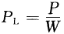...................................................(C.1) C.5.3 Uniform Load Calculation Formula:
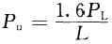 …………………………………………(C.2)
in the formula:
P — Force gauge reading, in kilonewtons (kN);
PL — linear load, measured in kilonewtons per meter (kN/m);
P —— Uniformly distributed load, measured in kilonewtons per square meter (kN/m²);

L — Span (distance between rollers), measured in meters (m);
W—nominal width of the sample, in meters (m); n—number of load-bearing flat steel bars in the sample;
N — Number of load-bearing flat steel bars per meter width. For example, when the center-to-center spacing of flat steel bars is 30mm, N=34/m; when the center-to-center spacing is
At 20mm, N=51/m.

Appendix D
（ informative annex ）
Safety load and deflection calculation of steel grating

D.1 Safe loadings for steel grating
computed strength ：
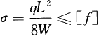............................................. (D.1) Uniformly distributed safety load:
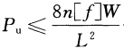(D.2) Safety Line Load:
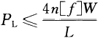.......................................... (D.3) where:
σ—Calculation intensity, in kilonewtons per square meter (kN/m²);
[f] —— Design value of material strength, unit is kN/m². For carbon structural steel, [f] = 170×10³kN/m²;
q — load intensity, measured in kilonewtons per meter (kN/m), representing the uniformly distributed load on each load-bearing flat steel bar, denoted as q=P./n;
Pa — uniformly distributed surface load, measured in kilonewtons per square meter (kN/m²);
PL — linear load, measured in kilonewtons per meter (kN/m);
n— Number of flat steel bars per meter of steel grating, n/m;
W —— bearing the moment of resistance of the flat steel section, where W=bt²/6mm³;
L — Span, in meters (m).
D.2 Relationship between uniform load and deflection
For flat steel section steel grating, it is simplified as follows:

in the formula:
ξ=758.5/(kN/m²);

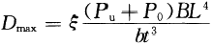

… ……………………………

(D.5)

q — load intensity, calculated as (P + P₀)B, measured in kilonewtons per meter (kN/m); E — elastic modulus, for carbon steel, E = 206×10⁶ kN/m²; q — load intensity, calculated as (P + P₀)B, measured in kilonewtons per meter (kN/m); E — elastic modulus, for carbon steel, E = 206×10⁶ kN/m²;
I —— Inertia moment of the cross-section, for flat steel I=bt³/12, in mm⁴; D —— Deflection, in mm;
P —— Uniformly distributed external load, measured in kilonewtons per square meter (kN/m²);
P₀ —self-weight of the steel grating, measured in kilonewtons per square meter (kN/m²); L —span, measured in meters (m);
B— Center distance of the bearing flat steel, in millimeters (mm); b— Thickness of the bearing flat steel, in millimeters (mm); t— Width of the bearing flat steel, in millimeters (mm)
D.3 Relationship between line load and deflection

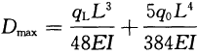

……………………………………

(D.6)

in the formula:
qL equals PLB, measured in kilonewtons (kN);
q₀ = P₀B, measured in kilonewtons per meter (kN/m).
For flat steel section steel grating, it is simplified as follows:

in the formula:

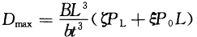

…………………………………(D.7)

PL — Additional line load, measured in kilonewtons per meter (kN/m); ζ=1213.6/ (kN/m²);
ξ=758.5/(kN/m²)。

Appendix E
（ informative annex ）
Safety load and deflection table

The safety load table in this appendix provides designers with a convenient way to query the load performance of steel grating. The table lists some commonly used steel grating models, the corresponding relationship between safety load and deflection at a certain net span, and the span from 200mm to 3000mm, increasing by 200mm.
The load table values are calculated based on the design strength of the material under static loads (170×10³kN/m² for carbon structural steel), including the weight of the steel grating. When designing steel grating for traffic roads, impact and fatigue factors should also be considered.
The numerical calculations for the load table are based on the nominal dimensions of the load-bearing flat steel. If the load-bearing flat steel has negative tolerance, a reduction factor should be considered. Similarly, any changes in the cross-sectional dimensions of the load-bearing flat steel due to punching, drilling, or slotting should also be accounted for.
The safety load table for the lockable steel grating is provided by the manufacturer.
The calculation of all load performance takes into account only the contribution of the bearing flat steel and ignores the crossbar.
The load table lists the data area, indicating that the maximum deflection of the model steel grating under the action of 2kN/m² uniform load is less than 4mm.
For the steel grating which is not listed in the table or used in the occasion of special requirements, the steel grating shall be produced and supplied by the supplier and the buyer according to the relevant provisions of this part.
Appendix Table E.1: Load-bearing flat steel with a 30mm center-to-center spacing welded steel grating.
Appendix Table E.2: Load-bearing flat steel with a 40mm center spacing welded steel grating.
Appendix Table E.3: Load-bearing flat steel with a 20mm center-to-center spacing welded steel grating.
Appendix Table E.4: The load-bearing flat steel is I-beam steel, with a 30mm center-to-center spacing, and the welded steel grating is compression-welded.
Appendix Table E.5 specifies that the flat steel is I-beam steel, with a 40mm center-to-center spacing, and the welded steel grating is compression-welded.
Appendix Table E.6 Heavy load pressure welded steel grating.
Appendix Table E.7: Relationship between the number of flat steel bars and nominal width of commonly used pressure-welded steel grating.

YB/T 4001.1—2007

Table E.1: Common Specifications and Safety Load Limits for Press-Welded Steel Grating with 30mm Spacing Between Flat Steel Bars

model | flat-rolled steel  width  mm | flat-rolled steel  thickness  mm | theory  weight  kg /m² |  | Span, mm
 |  |  |  |  | 200 | 400 | 600 | 800 | 1000 | 1200 | 1400 | 1600 | 1800 | 2000 | 2200 | 2400 | 2600 | 2800 | 3000
G655/30/50W | 65 | 5 | 103.4 | U | 3990 | 997 | 443 | 249 | 159 | 110 | 81 | 62 | 49 | 39 | 32 | 27 | 23 | 20 | 17
 |  |  |  | D | 0.11 | 0.42 | 0.95 | 1.7 | 2.65 | 3.81 | 5.22 | 6.84 | 8.7 | 10.61 | 2.82 | 15.4 | 18.18 | 21.4 | 24.18
G655/30/100W |  |  | 100.4 | C | 399 | 199 | 133 | 99 | 79 | 66 | 57 | 49 | 44 | 39 | 36 | 33 | 30 | 28 | 26
 |  |  |  | D | 0.08 | 0.34 | 0.76 | 1.35 | 2.11 | 3.06 | 4.21 | 5.43 | 6.98 | 8.54 | 10.56 | 12.65 | 14.75 | 17.33 | 19.97
G605/30/50W | 60 | 5 | 95.9 | U | 3400 | 850 | 377 | 212 | 136 | 94 | 69 | 53 | 41 | 34 | 28 | 23 | 20 | 17
 |  |  |  | D | 0.11 | 0.46 | 1.03 | 1.84 | 2.89 | 4.15 | 5.66 | 7.45 | 9.28 | 11.78 | 14.28 | 16.73 | 20.16 | 23.23
G605/30/100W |  |  | 92.9 | C | 340 | 170 | 113 | 85 | 68 | 56 | 48 | 42 | 37 | 34 | 30 | 28 | 26 | 24
 |  |  |  | D | 0.09 | 0.37 | 0.83 | 1.48 | 2.31 | 3.3 | 4.52 | 5.93 | 7.48 | 9.49 | 11.23 | 13.71 | 16.31 | 18.98
G555/30/50W | 55 | 5 | 88.4 | U | 2856 | 714 | 317 | 178 | 114 | 79 | 58 | 44 | 35 | 28 | 23 | 19 | 16
 |  |  |  | D | 0.13 | 0.5 | 1.13 | 2 | 3.14 | 4.53 | 6.19 | 8.04 | 10.3 | 12.63 | 15.29 | 18.03 | 21.08
G555/30/100W |  |  | 85.4 | C  D | 285 | 142 | 95 | 71 | 57 | 47 | 40 | 35 | 31 | 28 | 25 | 23 | 21
 |  |  |  |  | 0.1 | 0.4 | 0.9 | 1.6 | 2.52 | 3.6 | 4.89 | 6.43 | 8.16 | 10.18 | 12.2 | 14.7 | 17.24  ]
G505/30/50W | 50 | 5 | 80.9 | U | 2361 | 590 | 262 | 147 | 94 | 65 | 48 | 36 | 29 | 23 | 19 | 16
 |  |  |  | D | 0.14 | 0.55 | 1.24 | 2.2 | 3.45 | 4.97 | 6.82 | 8.78 | 11.39 | 13.86 | 16.88 | 20.28
G505/30/100W |  |  | 77.9 | C | 236 | 118 | 78 | 59 | 47 | 39 | 33 | 29 | 26 | 23 | 21 | 19
 |  |  |  | D | 0.11 | 0.44 | 0.99 | 1.77 | 2.77 | 3.99 | 5.39 | 7.11 | 9.14 | 11.18 | 13.7 | 16.26
G503/30/50W | 50 | 3 | 52.6 | U | 1416 | 354 | 157 | 88 | 56 | 39 | 28 | 22 | 17 | 14 | 11
 |  |  |  | D | 0.14 | 0.55 | 1.24 | 2.2 | 3.43 | 4.97 | 6.65 | 8.95 | 11.16 | 14.09 | 16.37  ]
G503/30/100W |  |  | 49.6 | C | 141 | 70 | 47 | 35 | 28 | 23 | 20 | 17 | 15 | 14 | 12
 |  |  |  | D | 0.11 | 0.44 | 0.99 | 1.75 | 2.75 | 3.92 | 5.45 | 6.97 | 8.82 | 11.37 | 13.14  ]
G455/30/50W | 45 | 5 | 73.4 | U | 1912 | 478 | 212 | 119 | 76 | 53 | 39 | 29 | 23 | 19 | 15
 |  |  |  | D | 0.15 | 0.61 | 1.38 | 2.45 | 3.83 | 5.56 | 7.62 | 9.73 | 12.44 | 5.76 | 18.39
G455/30/100W |  |  | 70.4 | C | 191 | 95 | 63 | 47 | 38 | 31 | 27 | 23 | 21 | 19 | 17
 |  |  |  | D | 0.12 | 0.49 | 1.09 | 1.94 | 3.07 | 4.35 | 6.06 | 7.76 | 10.16 | 12.72 | 15.3
G405/30/50W | 40 | 5 | 65.9 | U | 1511 | 377 | 167 | 94 | 60 | 41 | 30 | 23 | 18 | 15
 |  |  |  | D | 0.17 | 0.69 | 1.54 | 2.76 | 4.31 | 6.14 | 8.37 | 11.02 | 13.92 | 17.8
G405/30/100W |  |  | 62.9 | C | 151 | 75 | 50 | 37 | 30 | 25 | 21 | 18 | 16 | 15
 |  |  |  | D | 0.14 | 0.55 | 1.23 | 2.17 | 3.46 | 5.01 | 6.73 | 8.69 | 11.1 | 14.39
G403/30/50W | 40 | 3 | 43.3 | U | 906 | 226 | 100 | 56 | 36 | 25 | 18 | 14 | 11
 |  |  |  | D | 0.17 | 0.69 | 1.54 | 2.74 | 4.32 | 6.25 | 8.39 | 11.2 | 14.2
G403/30/100W |  |  | 40.3 | C | 90 | 45 | 30 | 22 | 18 | 15 | 12 | 11 | 10
 |  |  |  | D | 0.14 | 0.55 | 1.24 | 2.16 | 3.46 | 5.02 | 6.44 | 8.87 | 11.59

YB/T 4001.1—2007
Table E.1 (continued)

model | flat-rolled steel  width  mm | flat-rolled steel  thickness mm | theory  weight  kg /m² |  | Span, mm
 |  |  |  |  | 200 | 400 | 600 | 800 | 1000 | 1200 | 1400 | 1600 | 1800 | 2000 | 2200 | 2400 | 2600 | 2800 | 3000
G355/30/50W | 35 | 5 | 58.4 | U | 1156 | 289 | 128 | 72 | 46 | 32 | 23 | 18 | 14
 |  |  |  | D | 0.2 | 0.79 | 1.77 | 3.16 | 4.94 | 7.17 | 9.61 | 12.92 | 16.24
G355/30/100W |  |  | 55.4 | C | 115 | 57 | 38 | 28 | 23 | 19 | 16 | 14 | 12
 |  |  |  | D | 0.16 | 0.62 | 1.4 | 2.46 | 3.97 | 5.7 | 7.69 | 10.14 | 12.52
G353/30/50W | 35 | 3 | 38.6 | U | 694 | 173 | 77 | 43 | 27 | 19 | 14 | 10
 |  |  |  | D | 0.2 | 0.79 | 1.77 | 3.14 | 4.84 | 7.11 | 9.77 | 12.03
G353/30/100W |  |  | 35.6 | C | 69 | 34 | 23 | 17 | 13 | 11 | 9 | 8
 |  |  |  | D | 0.16 | 0.62 | 1.41 | 2.49 | 3.75 | 5.52 | 7.25 | 9.71
G325/30/50W | 32 | 5 | 53.9 | U | 967 | 241 | 107 | 60 | 38 | 26 | 19 | 15 | 11
 |  |  |  | D | 0.22 | 0.86 | 1.94 | 3.44 | 5.35 | 7.64 | 10.42 | 14.13 | 16.8
G325/30/100W |  |  | 50.9 | C | 96 | 48 | 32 | 24 | 19 | 16 | 13 | 12 | 10
 |  |  |  | D | 0.17 | 0.68 | 1.55 | 2.76 | 4.3 | 6.3 | 8.21 | 11.4 | 13.73
G323/30/50W | 32 | 3 | 35.8- | U | 580 | 145 | 64 | 36 | 23 | 16 | 11 | 9
 |  |  |  | D | 0.21 | 0.86 | 1.93 | 3.45 | 5.41 | 7.85 | 10.09 | 14.19
G323/30/100W |  |  | 32.8- | C | 58 | 29 | 19 | 14 | 11 | 9 | 8 | 7
 |  |  |  | D | 0.17 | 0.69 | 1.53 | 2.69 | 4.16 | 5.93 | 8.44 | 11.15
G255/30/50W | 25 | 5 | 43.4 | U | 590 | 147 | 65 | 36 | 23 | 16 | 12
 |  |  |  | D | 0.28 | 1.1 | 2.47 | 4.35 | 6.82 | 9.92 | 13.9
G255/30/100W |  |  | 40.4 | C | 59 | 29 | 19 | 14 | 11 | 9 | 8
 |  |  |  | D | 0.22 | 0.87 | 1.93 | 3.39 | 5.25 | 7.5 | 10.7
G253/30/50W | 25 | 3 | 29.3 | U | 354 | 88 | 39 | 22 | 14 | 9
 |  |  |  | D | 0.28 | 1.1 | 2.47 | 4.43 | 6.94 | 9.35
G253/30/100W |  |  | 26.3 | C | 35 | 17 | 11 | 8 | 7 | 5
 |  |  |  | D | 0.22 | 0.85 | 1.86 | 3.24 | 5.58 | 7
G205/30/50W | 20 | 5 | 36.0 | U | 377 | 94 | 41 | 23 | 15 | 10 |  | explain ：  1.U denotes the safety factor for steel grating under uniformly distributed loads, measured in kN/m².  2.C denotes the safety allowance for additional line loads acting perpendicular to the load-bearing flat steel along the centerline of the steel grating span, measured in kN/m.  3.D denotes the maximum deflection of the steel grating under the specified safety additional loads, measured in millimeters (mm).  4. List the data range indicating that the maximum deflection of the steel grid plate under the uniform load of 2kN/m² is less than 4mm;  5. Theoretical weight refers to the weight of a 1m long hot-dip galvanized steel grating.
 |  |  |  | D | 0.34 | 1.37 | 3.05 | 5.44 | 8.73 | 12.2
G205/30/100W |  |  | 33.0 | C | 37 | 18 | 12 | 9 | 7 | 6
 |  |  |  | D | 0.27 | 1.05 | 2.39 | 4.28 | 6.57 | 9.85
G203/30/50W | 20 | 3 | 24.6 up | U | 226 | 56 | 25 | 14 | 9
 |  |  |  | D | 0.34 | 1.37 | 3.1 | 5.53 | 8.76
G203/30/100W |  |  | 21.6 | C | 22 | 11 | 7 | 5 | 4
 |  |  |  | D | 0.27 | 1.07 | 2.32 | 3.98 | 6.3

model | flat-rolled steel  width  mm | flat-rolled steel  thickness  mm | theory  weight  kg /m² |  | span ，mm
 |  |  |  |  | 200 | 400 | 600 | 800 | 1000 | 1200 | 1400 | 1600 | 1800 | 2000 | 2200 | 2400 | 2600 | 2800 | 3000
G655/40/50W | 65 | 5 | 81.7 | U | 2992 | 748 | 332 | 187 | 119 | 83 | 61 | 46 | 36 | 29 | 24 | 20 | 17 | 15
 |  |  |  | D | 0.11 | 0.42 | 0.95 | 1.7 | 2.65 | 3.84 | 3.93 | 6.78 | 8.54 | 10.54 | 12.84 | 15.25 | 7.97 | 21.46
G655/40/100W |  |  | 78.7 | C | 299 | 149 | 99 | 74 | 59 | 49 | 42 | 37 | 33 | 29 | 27 | 24 | 23 | 21
 |  |  |  | D | 0.08 | 0.34 | 0.76 | 1.35 | 2.1 | 3.03 | 4.14 | 5.47 | 6.99 | 8.49 | 10.58 | 12.32 | 15.1 | 17.39
G605/40/50W | 60 | 5 | 75.9 | U | 2550 | 637 | 283 | 159 | 102 | 70 | 52 | 39 | 31 | 25 | 21 | 17 | 15
 |  |  |  | D | 0.11 | 0.46 | 1.03 | 1.84 | 2.89 | 4.12 | 4.27 | 7.32 | 9.36 | 11.5 | 714.3 | 116.5 | 420.21
G605/40/100W |  |  | 72.9- | C | 255 | 127 | 85 | 63 | 51 | 42 | 36 | 31 | 28 | 25 | 23 | 21 | 19
 |  |  |  | D | (  0.09 | 0.37 | 0.83 | 1.46 | 2.31 | 3.31 | 4.52 | 5.84 | 7.56 | 9.32 | 11.5 | 13.74 | 15.97
G555/40/50W | 55 | 5 | 70. | U | 2142 | 535 | 238 | 133 | 85 | 59 | 43 | 33 | 26 | 21 | 17 | 14
 |  |  |  | D | I0.13 | 0.5 | 1.13 | 2 | 3.13 | 4.51 | 5.59 | 8.05 | 10.22 | 12.66 | 15.11 | 17.77
G555/40/100W |  |  | 67.1 | C | 214 | 107 | 71 | 53 | 42 | 35 | 30 | 26 | 23 | 21 | 19 | 17
 |  |  |  | D | 0.1 | 0.4 | 0.9 | 1.59 | 2.48 | 3.58 | 4.9 | 6.38 | 8.09 | 10.2 | 12.39 | 14.54
G505/40/50W | 50 | 5 | 64.2 | U | 1770 | 442 | 196 | 110 | 70 | 49 | 36 | 27 | 21 | 17 | 14
 |  |  |  | D | 0.14 | 0.55 | 1.24 | 2.2 | 3.43 | 5 | 5.12 | 8.79 | 11.02 | 13.69 | 16.64
G505/40/100W |  |  | 61.2 | C | 177 | 88 | 59 | 44 | 35 | 29 | 25 | 22 | 19 | 17 | 16
 |  |  |  | D | 0.11 | 0.44 | 0.99 | 1.76 | 2.75 | 3.96 | 5.45 | 7.2 | 8.93 | 11.05 | 13.95
G503/40/50W | 50 | 3 | 42.6 | U | 1062 | 265 | 118 | 66 | 42 | 29 | 21 | 16 | 13 | 10
 |  |  |  | D | 0.14 | 0.55 | 1.24 | 2.2 | 3.43 | 4.94 | 4.99 | 8.71 | 11.4 | 13.49
G503/40/100W |  |  | 39.6 | C | 106 | 53 | 35 | 26 | 21 | 17 | 15 | 13 | 11 | 10
 |  |  |  | D | 0.11 | 0.44 | 0.98 | 1.74 | 2.75 | 3.87 | 5.46 | 7.11 | 8.66 | 10.9
G455/40/50W | 45 | 5 | 58.4 | U | 1434 | 358 | 159 | 89 | 57 | 39 | 29 | 22 | 17 | 14 | 11
 |  |  |  | D | 0.15 | 0.61 | 1.38 | 2.44 | 3.83 | 5.46 | 5.67 | 9.85 | 12.28 | 15.53 | 18.05
G455/40/100W |  |  | 55.4 | C | 143 | 71 | 47 | 35 | 28 | 23 | 20 | 17 | 15 | 14 | 13
 |  |  |  | D | 0.12 | 0.49 | 1.09 | 1.92 | 3.02 | 4.31 | 5.99 | 7.67 | 9.72 | 12.54 | 15.64
G405/40/50W | 40 | 5 | 52.6 | U | 1133 | 283 | 125 | 70 | 45 | 31 | 23 | 17 | 13 | 11
 |  |  |  | D | 0.17 | 0.69 | 1.54 | 2.74 | 4.32 | 6.2 | 6.42 | 10.88 | 13.45 | 17.47
G405/40/100W |  |  | 49.6 | C | 113 | 56 | 37 | 28 | 22 | 18 | 16 | 14 | 12 | 11
 |  |  |  | D | 0.14 | 0.54 | 1.22 | 2.19 | 3.39 | 4.82 | 6.85 | 9.02 | 11.13 | 14.13
G403/40/50W | 40 | 3 | 35.3 | U | 680 | 170 | 75 | 42 | 27 | 18 | 13 | 10 | 8
 |  |  |  | D | 0.17 | 0.69 | 1.54 | 2.74 | 4.32 | 6.01 | 6.08 | 10.7 | 13.84
G403/40/100W |  |  | 32.3 | C | 68 | 34 | 22 | 17 | 13 | 11 | 9 | 8 | 7
 |  |  |  | D | 0.14 | 0.55 | 1.21 | 2.22 | 3.34 | 4.92 | 6.45 | 8.64 | 10.9

YB/T 4001.1—2007

Table E.2 (continued)

model | flat-rolled steel  width mm | flat-rolled steel  thickness mm | theory  weight  kg /m² |  | Span, mm
 |  |  |  |  | 200 | 400 | 600 | 800 | 1000 | 1200 | 1400 | 1600 | 1800 | 2000 | 2200 | 2400 | 2600 | 2800 | 3000
G355/40/50W | 35 | 5 | 46.8 | U | 867 | 216 | 96 | 54 | 34 | 24 | 17 | 13 | 10
 |  |  |  | D | 0.2 | 0.78 | 1.77 | 3.16 | 4.88 | 7.18 | 7.12 | 12.48 | 15.54
G355/40/100W |  |  | 43.8 | C | 86 | 43 | 28 | 21 | 17 | 14 | 12 | 10 | 9
 |  |  |  | D | 0.16 | 0.62 | 1.38 | 2.46 | 3.91 | 5.61 | 7.71 | 9.7 | 12.57
G353/40/50W | 35 | 3 | 31.6 | U | 520 | 130 | 57 | 32 | 20 | 14 | 10 | 8
 |  |  |  | D | 0.2 | 0.79 | 1.75 | 3.12 | 4.79 | 7 | 7.01 | 12.85
G353/40/100W |  |  | 28.6 | C | 52 | 28 | 17 | 13 | 10 | 8 | 7 | 6
 |  |  |  | D | 0.16 | 0.63 | 1.4 | 2.54 | 3.85 | 5.37 | 7.53 | 9.75
G325/40/50W | 32 | 5 | 43.3 | U | 725 | 181 | 80 | 45 | 29 | 20 | 14 | 11
 |  |  |  | D | 0.21 | 0.86 | 1.93 | 3.45 | 5.45 | 7.84 | 7.7 | 13.86
G325/40/100W |  |  | 40.3 | C | 72 | 36 | 24 | 18 | 14 | 12 | 10 | 9
 |  |  |  | D | 0.17 | 0.68 | 1.55 | 2.76 | 4.23 | 6.31 | 8.43 | 11.44
G323/40/50W | 32 | 3 | 29.4 | U | 435 | 108 | 48 | 27 | 17 | 12 | 8
 |  |  |  | D | 0.21 | 0.86 | 1.93 | 3.45 | 5.34 | 7.86 | 7.37
G323/40/100W |  |  | 26.4 | C | 43 | 21 | 14 | 10 | 8 | 7 | 6
 |  |  |  | D | 0.17 | 0.67 | 1.5 | 2.56 | 4.04 | 6.16 | 8.47
G255/40/50W | 25 | 5 | 35.1 | U | 442 | 110 | 49 | 27 | 17 | 12 | 9
 |  |  |  | D | 0.27 | 1.1 | 2.48 | 4.35 | 6.74 | 9.94 | 10.46
G255/40/100W |  |  | 32.1 | C | 44 | 22 | 14 | 11 | 8 | 7 | 6
 |  |  |  | D | 0.22 | 0.88 | 1.9 | 3.55 | 5.1 | 7.79 | 10.74
G253/40/50W | 25 | 3 | 24.3 | U | 265 | 66 | 29 | 16 | 10 | 7
 |  |  |  | D | 0.27 | 1.1 | 2.45 | 4.3 | 6.63 | 9.71
G253/40/100W |  |  | 21.3 | C | 26 | 13 | 8 | 6 | 5 | 4
 |  |  |  | D | 0.22 | 0.87 | 1.81 | 3.24 | 5.33 | 7.48
G205/40/50W | 20 | 5 | 29.3 | U | 283 | 70 | 31 | 17 | 11 | 7 |  | explain ：  1.U denotes the safety factor for steel grating under uniformly distributed loads, measured in kN/m².  2.C denotes the safety allowance for additional line loads acting perpendicular to the load-bearing flat steel along the centerline of the steel grating span, measured in kN/m.  3.D denotes the maximum deflection of the steel grating under the specified safety additional loads, measured in millimeters (mm).  4. List the data range indicating that the maximum deflection of the steel grid plate under the uniform load of 2kN/m² is less than 4mm;  5. Theoretical weight refers to the weight of a 1m long hot-dip galvanized steel grating.
 |  |  |  | D | 0.34 | 1.36 | 3.08 | 5.37 | 8.56 | 11.46
G205/40/100W |  |  | 26.3 | C | 28 | 14 | 9 | 7 | 5 | 4
 |  |  |  | D | 0.27 | 1.09 | 2.39 | 4.44 | 6.29 | 8.84
G203/40/50W | 20 | 3 | 20.6 | U | 170 | 42 | 18 | 10 | 6
 |  |  |  | D | 0.34 | 1.37 | 2.98 | 5.28 | 7.84
G203/40/100W |  |  | 17.6 | C | 17 | 8 | 5 | 4 | 3
 |  |  |  | D | 0.28 | 1.04 | 2.22 | 4.25 | 6.32

model | flat-rolled steel  width mm | flat-rolled steel  thickness mm | theory  weight  kg /m² |  | Span, mm
 |  |  |  |  | 200 | 400 | 600 | 800 | 1000 | 1200 | 1400 | 1600 | 1800 | 2000 | 2200 | 2400 | 2600 | 2800 | 3000
G605/20/50W | 60 | 5 | 138.3 | U | 5100 | 1275 | 566 | 318 | 204 | 141 | 104 | 79 | 62 | 51 | 42 | 35 | 30 | 26 | 22
 |  |  |  | D | 0.11 | 0.46 | 1.03 | 1.84 | 2.88 | 4.15 | 5.69 | 7.4 | 9.34 | 11.77 | 14.27 | 16.94 | 20.13 | 23.62 | 26.57
G605/20/100W |  |  | 35.3 | C | 510 | 255 | 170 | 127 | 102 | 85 | 72 | 63 | 56 | 51 | 46 | 42 | 39 | 36 | 34
 |  |  |  | D | 0.09 | 0.37 | 0.83 | 1.47 | 2.31 | 3.34 | 4.51 | 5.92 | 7.54 | 9.47 | 11.45 | 13.68 | 16.28 | 18.93 | 22.17
G555/20/50W | 55 | 5 | 127.3 | U | 4285 | 1071 | 476 | 267 | 171 | 119 | 87 | 66 | 52 | 42 | 35 | 29 | 25 | 21
 |  |  |  | D | 0.13 | 0.5 | 1.13 | 2 | 3.14 | 4.55 | 6.18 | 8.04 | 10.19 | 12.62 | 15.48 | 18.3 | 21.87 | 24.94
G555/20/100W |  |  | 124.3 | C | 428 | 214 | 142 | 107 | 85 | 71 | 61 | 53 | 47 | 42 | 38 | 35 | 32 | 30
 |  |  |  | D | 0.1 | 0.4 | 0.9 | 1.61 | 2.5 | 3.63 | 4.97 | 6.48 | 8.24 | 10.17 | 12.34 | 14.87 | 17.45 | 520.6
G505/20/50W | 50 | 5 | 116.3 | U | 3541 | 885 | 393 | 221 | 141 | 98 | 72 | 55 | 43 | 35 | 29 | 24 | 20
 |  |  |  | D | 0.14 | 0.55 | 1.24 | 2.21 | 3.45 | 4.99 | 6.82 | 8.93 | 11.25] | 14.03 | 17.14 | 20.24 | 23.45
G505/20/100W |  |  | 113.3 | C | 354 | 177 | 118 | 88 | 70 | 59 | 50 | 44 | 39 | 35 | 32 | 29 | 27
 |  |  |  | D | 0.11 | 0.44 | 0.99 | 1.76 | 2.75 | 4.02 | 5.43 | 7.18 | 9.12 | 11.32 | 13.88 | 16.49 | 19.69
G503/20/50W | 50 | 3 | 73.8 | U | 2125 | 531 | 236 | 132 | 85 | 59 | 43 | 33 | 26 | 21 | 17 | 14
 |  |  |  | D | 0.14 | 0.55 | 1.24 | 2.2 | 3.47 | 5.01 | 6.79 | 8.94 | 11.35 | 14.C6 | 16.8 | 19.76
G503/20/100W |  |  | 70.8 | C | 212 | 106 | 70 | 53 | 42 | 35 | 30 | 26 | 23 | 21 | 19 | 17
 |  |  |  | D | 0.11 | 0.44 | 0.98 | 1.77 | 2.75 | 3.98 | 5.44 | 7.08 | 8.99 | 11.34 | 13.78 | 16.18
G455/20/50W | 45 | 5 | 105.2 | U | 2868 | 717 | 318 | 179 | 114 | 79 | 58 | 44 | 35 | 28 | 23 | 19
 |  |  |  | D | 0.15 | 0.61 | 1.38 | 2.46 | 3.83 | 5.53 | 7.55 | 9.83 | 12.59 | 15.47 | 18.74 | 22.13
G455/20/100W |  |  | 102.2 | C | 286 | 143 | 95 | 71 | 57 | 47 | 40 | 35 | 31 | 28 | 26 | 23
 |  |  |  | D | ·0.12 | 0.49 | 1.1 | 1.95 | 3.07 | 4.4 | 5.98 | 7.86 | 9.99 | 12.48 | 15.55 | 18.08
G405/20/50W | 40 | 5 | 94.2 | U | 2266 | 566 | 251 | 141 | 90 | 62 | 46 | 35 | 27 | 22 | 18
 |  |  |  | D | 0.17 | 0.69 | 1.55 | 2.76 | 4.31 | 6.19 | 8.55 | 11.16 | 13.9 | 17.39 | 21.0
G405/20/100W |  |  | 91.2 | C | 226 | 113 | 75 | 56 | 45 | 37 | 32 | 28 | 25 | 22 | 20
 |  |  |  | D | 0.14 | 0.55 | 1.23 | 2.19 | 3.46 | 4.94 | 6.83 | 8.99 | 11.52 | 4.0 | 517.18
G403/20/50W | 40 | 3 | 60.3 | U | 1360 | 340 | 151 | 85 | 54 | 37 | 27 | 21 | 16 | 13
 |  |  |  | D | 0.17 | 0.69 | 1.55 | 2.77 | 4.31 | 6.16 | 8.37 | 11.1 | 813.76 | 17.18
G403/20/100W |  |  | 57.3 | C | 136 | 68 | 45 | 34 | 27 | 22 | 19 | 17 | 15 | 13
 |  |  |  | D | 0.14 | 0.55 | 1.23 | 2.22 | 3.46 | 4.9 | 6.77 | 9.11 | 11.55 | 13.89
G355/20/50W | 35 | 5 | 83.2 | U | 1735 | 433 | 192 | 108 | 69 | 48 | 35 | 27 | 21 | 17
 |  |  |  | D | 0.2 | 0.79 | 1.77 | 3.15 | 4.94 | 7.16 | 9.74 | 12.9 | 16.21 | 20.17
G355/20/100W |  |  | 80.2 | C | 173 | 86 | 57 | 43 | 34 | 28 | 24 | 21 | 19 | 17
 |  |  |  | D | 0.16 | 0.62 | 1.4 | 2.52 | 3.91 | 5.6 | 7.68 | 10.12 | 13.15 | 16.32

YB/T 4001.1—2007
Table E.3 (continued)
-
model | flat-rolled steel  width  mm | flat-rolled steel  thickness  mm | theory  weight  kg  /m² |  | Span, mm
 |  |  |  |  | 200 | 400 | 600 | 800 | 1000 | 1200 | 1400 | 1600 | 1800 | 2000 | 2200 | 2400 | 2600 | 2800 | 3000
G353/20/50W | 35 | 3 | 53.5 | U | 1041 | 260 | 115 | 65 | 41 | 28 | 21 | 16 | 12
 |  |  |  | D | 0.2 | 0.79 | 1.77 | 3.17 | 4.9 | 6.98 | 9.75 | 12.77 | 15.5
G353/20/100W |  |  | 50.5 | C | 104 | 52 | 34 | 26 | 20 | 17 | 14 | 13 | 11
 |  |  |  | D | 0.16 | 0.63 | 1.39 | 2.54 | 3.84 | 5.67 | 7.49 | 10.45 | 12.75
G325/20/50W | 32 | 5 | 76.6 | U | 1450 | 362 | 161 | 90 | 58 | 40 | 29 | 22 | 17 | 14
 |  |  |  | D | 0.21 | 0.86 | 1.94 | 3.44 | 5.44 | 7.82 | 10.58 | 13.8 | 17.25 | 21.85
G325/20/100W |  |  | 73.6 | C | 145 | 72 | 48 | 36 | 29 | 24 | 20 | 18 | 16 | 14
 |  |  |  | D | 0.17 | 0.68 | 1.54 | 2.76 | 4.37 | 6.29 | 8.4 | 11.38 | 14.55 | 17.7
G323/20/50W | 32 | 3 | 49.4 | U | 870 | 217 | 96 | 54 | 34 | 24 | 17 | 13 | 10
 |  |  |  | D | 0.21 | 0.86 | 1.93 | 3.44 | 5.32 | 7.83 | 10.37 | 13.64 | 16.98
G323/20/100W |  |  | 46.4 | C | 87 | 43 | 29 | 21 | 17 | 14 | 12 | 10 | 9
 |  |  |  | D | 0.17 | 0.68 | 1.56 | 2.69 | 4.27 | 6.13 | 8.42 | 10.6 | 13.74
G255/20/50W | 25 | 5 | 61.1 | U | 885 | 221 | 98 | 55 | 35 | 24 | 18 | 13
 |  |  |  | D | 0.28 | 1.1 | 2.48 | 4.42 | 6.91 | 9.9 | 13.87 | 17.3
G255/20/100W |  |  | 58.1 | C | 88 | 44 | 29 | 22 | 17 | 14 | 12 | 11
 |  |  |  | D | 0.22 | 0.88 | 1.96 | 3.55 | 5.4 | 7.76 | 10.68 | 14.76
G253/20/50W | 25 | 3 | 39.9 | U | 531 | 132 | 59 | 33 | 21 | 14 | 10
 |  |  |  | D | 0.28 | 1.1 | 2.49 | 4.43 | 6.92 | 9.66 | 12.92
G253/20/100W |  |  | 36.9 | C | 53 | 26 | 17 | 13 | 10 | 8 | 7
 |  |  |  | D | 0.22 | 0.86 | 1.92 | 3.5 | 5.3 | 7.42 | 10.43
G205/20/50W | 20 | 5 | 50.1 | U | 566 | 141 | 62 | 35 | 22 | 15 | 11 | explain ：  1.U denotes the safety factor for steel grating under uniformly distributed loads, measured in kN/m².  2.C denotes the safety allowance for additional line loads acting perpendicular to the load-bearing flat steel along the centerline of the steel grating span, measured in kN/m.  3.D denotes the maximum deflection of the steel grating under the specified safety additional loads, measured in millimeters (mm).  4. List the data range indicating that the maximum deflection of the steel grid plate under the uniform load of 2kN/m² is less than 4mm;  5. Theoretical weight refers to the weight of a 1m long hot-dip galvanized steel grating.
 |  |  |  | D | 0.34 | 1.37 | 3.07 | 5.51 | 8.53 | 12.18 | 16.74
G205/20/100W |  |  | 47.1 | C | 56 | 28 | 18 | 14 | 11 | 9 | 8
 |  |  |  | D | 0.27 | 1.09 | 2.38 | 4.43 | 6.86 | 9.82 | 14.04
G203/20/50W | 20 | 3 | 33.1 | U | 340 | 85 | 37 | 21 | 13 | 9
 |  |  |  | D | 0.34 | 1.38 | 3.06 | 5.52 | 8.42 | 12.22
G203/20/100W |  |  | 30.1 | C | 34 | 17 | 11 | 8 | 6 | 5
 |  |  |  | D | 0.28 | 1.11 | 2.43 | 4.23 | 6.27 | 9.16

YB/T 4001.1—2007
Table E.4: Common Specifications and Safety Loadings for Press-Welded Steel Grating with 30mm Spacing Between Type I Steel Bars

model | merchant steel  width mm | flange  thickness mm | belly  thickness mm | flange  width mm | Theoretical weight kg/m² |  | Span, mm
 |  |  |  |  |  |  | 200 | 400 | 600 | 800 | 1000 | 1200 | 1400 | 1600 | 1800 | 2000 | 2200 | 2400 | 2600 | 2800 | 3000
G757/30/50WI | 75 | 7 | 4 | 12 | 126.1 | Ul | 6460 | 1615 | 717 | 403 | 258 | 179 | 131 | 100 | 79 | 64 | 53 | 44 | 38 | 32 | 28
 |  |  |  |  |  | D | 0.09 | 0.37 | 0.83 | 1.47 | 2.3 | 3.31 | 4.5 | 5.88 | 7.47 | 9.25 | 11.26 | 13.3 | 15.89 | ]18.1 | 20.99
G757/30/100WI |  |  |  |  | 120.7 | C | 646 | 323 | 215 | 161 | 129 | 107 | 92 | 80 | 71 | 64 | 58 | 53 | 49 | 46 | 43
 |  |  |  |  |  | D | 0.07 | 0.29 | 0.66 | 1.17 | 1.84 | 2.65 | 3.62 | 4.72 | 5.99 | 7.44 | 9.02 | 10.76 | 12.72 | 15 | 17.36
G657/30/50WI | 65 | 7 | 4 | 10 | 110.1 | U | 4862 | 1215 | 540 | 303 | 194 | 135 | 99 | 75 | 60 | 48 | 40 | 33 | 28 | 24 | 21
 |  |  |  |  |  | D | 0.11 | 0.42 | 0.95 | 1.69 | 2.65 | 3.83 | 5.22 | 6.77 | 8.71 | 10.67 | 3.07 | 15.3 | 618.05 | 20.94 | 24.29
G657/30/100WI |  |  |  |  | 104.8 | C | 486 | 243 | 162 | 121 | 97 | 81 | 69 | 60 | 54 | 48 | 44 | 40 | 37 | 34 | 32
 |  |  |  |  |  | D | 0.08 | 0.34 | 0.76 | 1.35 | 2.12 | 3.07 | 4.17 | 5.44 | 7 | 8.58 | 10.53 | 12.5 | 14.8 | 17.12 | 19.96
G607/30/50WI | 60 | 7 | 4 | 10 | 99.1 | U | 4216 | 1054 | 468 | 263 | 168 | 117 | 86 | 65 | 52 | 42 | 34 | 29 | 24 | 21 | 18
 |  |  |  |  |  | D | 0.11 | 0.46 | 1.03 | 1.83 | 2.86 | 4.13 | 5.65 | 7.31 | 9.4 | 11.62 | 13.85 | 16.8 | 19.29 | 22.82 | 25.97
G607/30/100WI |  |  |  |  | 96.1 | C | 421 | 210 | 140 | 105 | 84 | 70 | 60 | 52 | 46 | 42 | 38 | 35 | 32 | 30 | 28
 |  |  |  |  |  | D | 0.09 | 0.36 | 0.82 | 1.46 | 2.29 | 3.3 | 4.52 | 5.87 | 7.43 | 9.35 | 11.33 | 13.63 | 15.96 | 18.82 | 21.77
G557/30/50WI | 55 | 7 | 4 | 8.5- | 90.3 | U | 3502 | 875 | 389 | 218 | 140 | 97 | 71 | 54 | 43 | 35 | 28 | 24 | 20 | 17
 |  |  |  |  |  | D | 0.13 | 0.5 | 1.13 | 2 | 3.15 | 4.53 | 6.17 | 8.03 | 10.29 | 12.82 | 15.11 | 18.44 | 21.32 | 24.55
G557/30/100WI |  |  |  |  | 87.3 | C | 350 | 175 | 116 | 87 | 70 | 58 | 50 | 43 | 38 | 35 | 31 | 29 | 26 | 25
 |  |  |  |  |  | D | 0.1 | 0.4 | 0.9 | 1.6 | 2.52 | 3.62 | 4.98 | 6.42 | 8.13 | 10.32 | 12.26 | 14.98 | 17.23 | 20.83
G507/30/50WI | 50 | 7 | 4 | 8 | 83.2 | U | 2912 | 728 | 323 | 182 | 116 | 80 | 59 | 45 | 35 | 29 | 24 | 20 | 17
 |  |  |  |  |  | D | 0.14 | 0.55 | 1.24 | 2.21 | 3.44 | 4.94 | 6.78 | 8.85 | 11.09 | 14.07 | 17.14 | 20.37 | 24.0
G507/30/100WI |  |  |  |  | 80.2 | C | 291 | 145 | 97 | 72 | 58 | 48 | 41 | 36 | 32 | 29 | 26 | 24 | 22
 |  |  |  |  |  | Dl | 0.11 | 0.44 | 0.99 | 1.75 | 2.76 | 3.96 | 5.4 | 7.12 | 9.06 | 11.33 | 13.63 | 16.45 | 19.34
G505/30/50WI | 50 | 5 | 3 | 8.5 | 62.8 | U | 2085 | 521 | 231 | 130 | 83 | 57 | 42 | 32 | 25 | 20 | 17 | 14
 |  |  |  |  |  | D | 0.14 | 0.55 | 1.23 | 2.2 | 3.44 | 4.91 | 6.73 | 8.79 | 11.06 | 13.57 | 16.97 | 19.95
G505/30/100WI |  |  |  |  | 59.8 | C | 208 | 104 | 69 | 52 | 41 | 34 | 29 | 26 | 23 | 20 | 18 | 17
 |  |  |  |  |  | D | 0.11 | 0.44 | 0.98 | 1.76 | 2.72 | 3.92 | 5.33 | 7.17 | 9.09 | 10.94 | 13.2 | 16.3
G445/30/50WI | 44 | 5 | 3 | 8 | 56.5 | U | 1654 | 413 | 183 | 103 | 66 | 45 | 33 | 25 | 20 | 16 | 13
 |  |  |  |  |  | D | 0.16 | 0.62 | 1.4 | 2.5 | 3.92 | 5.56 | 7.59 | 9.86 | 12.71 | 15.6 | 18.7
G45/30/100WI |  |  |  |  | 53.5 | C | 165 | 82 | 55 | 41 | 33 | 27 | 23 | 20 | 18 | 16 | 15
 |  |  |  |  |  | D | 0.12 | 0.5 | 1.12 | 1.99 | 3.14 | 4.46 | 6.07 | 7.93 | 10.23 | 12.58 | 15.81
G385/30/50WI | 38 | 5 | 3 | 7 | 49.9 | U | 1246 | 311 | 138 | 77 | 49 | 34 | 25 | 19 | 15 | 12
 |  |  |  |  |  | D | 0.18 | 0.73 | 1.64 | 2.89 | 4.51 | 6.52 | 8.93 | 11.64 | 14.82 | 18.22
G385/30/100WI |  |  |  |  | 46.9 | C | 124 | 62 | 41 | 31 | 24 | 20 | 17 | 15 | 13 | 12
 |  |  |  |  |  | D | 0.14 | 0.58 | 1.3 | 2.33 | 3.55 | 5.13 | 6.98 | 9.25 | 11.53 | 14.72
G325/30/50WI | 32 | 5 | 3 | 6 | 43.3 | U | 884 | 221 | 98 | 55 | 35 | 24 | 18 | 13 | 10
 |  |  |  |  |  | D | 0.21 | 0.86 | 1.94 | 3.44 | 5.37 | 7.68 | 10.74 | 13.35 | 16.6
G325/30/100WI |  |  |  |  | 40.3 | C | 88 | 44 | 29 | 22 | 17 | 14 | 12 | 11 | 9
 |  |  |  |  |  | D | 0.17 | 0.69 | 1.53 | 2.76 | 4.19 | 6.01 | 8.24 | 11.36 | 13.42
G255/30/50WI | 25 | 5 | 3 | 4.5- | 35.1 | U | 544 | 136 | 60 | 34 | 21 | 15 | 11
 |  |  |  |  |  | D | 0.28 | 1.1 | 2.47 | 4.45 | 6.75 | 10.06 | 13.77
G255/30/100WI |  |  |  |  | 32.1 | C | 54 | 27 | 18 | 13 | 10 | 9 | 7
 |  |  |  |  |  | D | 0.22 | 0.88 | 1.98 | 3.41 | 5.17 | 8.09 | 10.13
explain ：
1.U denotes the safety factor for steel grating under uniformly distributed loads, measured in kN/m².
2.C denotes the safety allowance for additional line loads acting perpendicular to the load-bearing flat steel along the centerline of the steel grating span, measured in kN/m.
3.D denotes the maximum deflection of the steel grating under the specified safety additional loads, measured in millimeters (mm).
4. List the data range indicating that the maximum deflection of the steel grid plate under the uniform distribution load of 2kN/m² is less than 4mm;
5. Theoretical weight refers to the weight of a 1m long hot-dip galvanized steel grating.

YB/T 4001.1—2007

Table E.5: Common Specifications and Safety Loadings for Press-Welded Steel Grating with 40mm Spacing Between Type I Steel Bars

model | merchant steel  width mm | Flange thickness mm | belly  thickness mm | flange  width mm | theory  weight kg/m² |  | Span, mm
 |  |  |  |  |  |  | 200 | 400 | 600 | 800 | 1000 | 1200 | 1400 | 1600 | 1800 | 2000 | 2200 | 2400 | 2600 | 2800 | 3000
G757/40/50WI | 75 | 7 | 4 | 12 | 101 | U | 4845 | 1211 | 538 | 302 | 193 | 134 | 98 | 75 | 75 | 59 | 48 | 40 | 33 | 28 | 24
 |  |  |  |  |  | D | 0.09 | 0.37 | 0.83 | 1.47 | 2.29 | 3.31 | 4.49 | 5.89 | 5.89 | 7.44 | 9.27 | 11.35 | 13.33 | 15.66 | 18.16
G757/40/100WI |  |  |  |  | 95.6 | C | 484 | 242 | 161 | 121 | 96 | 80 | 69 | 60 | 60 | 53 | 48 | 44 | 40 | 37 | 34
 |  |  |  |  |  | D | 0.07 | 0.29 | 0.66 | 1.18 | 1.83 | 2.64 | 3.63 | 4.72 | 4.72 | 5.97 | 7.45 | 9.13 | 10.85 | 12.83 | 14.83
G657/40/50WI | 65 | 7 | 4 | 10 | 88.5 | U | 3646 | 911 | 405 | 227 | 145 | 101 | 74 | 56 | 56 | 45 | 36 | 30 | 25 | 21 | 18
 |  |  |  |  |  | D | 0.11 | 0.42 | 0.95 | 1.69 | 2.64 | 3.83 | 5.21 | 6.75 | 6.75 | 8.72 | 10.68 | 13.1 | 15.54 | 18.1 | 21
G657/40/100WI |  |  |  |  | 83.2 | C | 364 | 182 | 121 | 91 | 72 | 60 | 52 | 45 | 45 | 40 | 36 | 33 | 30 | 28 | 26
 |  |  |  |  |  | D | 0.08 | 0.34 | 0.76 | 1.36 | 2.1 | 3.04 | 4.2 | 5.44 | 5.44 | 6.92 | 8.6 | 10.55 | 12.54 | 14.98 | 17.5
G607/40/50WI | 60 | 7 | 4 | 10 | 78.9 | U | 3162 | 790 | 351 | 197 | 126 | 87 | 64 | 49 | 49 | 39 | 31 | 26 | 21 | 18 | 16
 |  |  |  |  |  | D | 0.11 | 0.46 | 1.03 | 1.83 | 2.86 | 4.1 | 5.61 | 7.35 | 7.35 | 9.41 | 11.46 | 14.13 | 16.28 | 19.33 | 23.23
G607/40/100WI |  |  |  |  | 75.9 | C | 316 | 158 | 105 | 79 | 63 | 52 | 45 | 39 | 39 | 35 | 31 | 28 | 26 | 24 | 22
 |  |  |  |  |  | D | 0.09 | 0.37 | 0.82 | 1.47 | 2.29 | 3.28 | 4.52 | 5.87 | 5.87 | 7.54 | 9.22 | 11.16 | 13.54 | 16 | 18.48
G557/40/50WI | 55 | 7 | 4 | 8.5 | 71.9 | U | 2626 | 656 | 291 | 164 | 105 | 72 | 53 | 41 | 41 | 32 | 26 | 21 | 18 | 15
 |  |  |  |  |  | D | 0.13 | 0.5 | 1.13 | 2.01 | 3.15 | 4.49 | 6.14 | 8.14 | 8.14 | 10.22 | 12.72 | 15.14 | 18.48 | 21.37
G557/40/100WI |  |  |  |  | -  68.9 | C | 262 | 131 | 87 | 65 | 52 | 43 | 37 | 32 | 32 | 29 | 26 | 23 | 21 | 20
 |  |  |  |  |  | D | 0.1 | 0.4 | 0.9 | 1.59 | 2.5 | 3.58 | 4.92 | 6.38 | 6.38 | 8.28 | 10.25 | 12.16 | 14.53 | 17.71
G507/40/50WI | 50 | 7 | 4 | 8 | 66.4 | U | 2184 | 546 | 242 | 136 | 87 | 60 | 44 | 34 | 34 | 26 | 21 | 18 | 15
 |  |  |  |  |  | D | 0.14 | 0.55 | 1.24 | 2.2 | 3.45 | 4.95 | 6.74 | 8.93 | 8.93 | 11 | 13.62 | 17.18 | 20.42
G507/40/100WI |  |  |  |  | 63.4 | C | 218 | 109 | 72 | 54 | 43 | 36 | 31 | 27 | 27 | 24 | 21 | 19 | 18
 |  |  |  |  |  | D | 0.11 | 0.44 | 0.98 | 1.75 | 2.73 | 3.97 | 5.45 | 7.13 | 7.13 | 9.07 | 10.98 | 13.33 | 16.5
G505/40/50WI | 50 | 5 | 3 | 8.5 | 50.4 | U | 1564 | 391 | 173 | 97 | 62 | 43 | 31 | 24 | 24 | 19 | 15 | 12
 |  |  |  |  |  | D | 0.14 | 0.55 | 1.23 | 2.19 | 3.43 | 4.95 | 6.64 | 8.8 | 8.8 | 11.22 | 13.6 | 16.05
G505/40/100WI |  |  |  |  | 47.4 | C | 156 | 78 | 52 | 39 | 31 | 26 | 22 | 19 | 19 | 17 | 15 | 14
 |  |  |  |  |  | D | 0.11 | 0.44 | 0.99 | 1.76 | 2.75 | 4 | 5.4 | 7.01 | 7.01 | 8.98 | 10.96 | 13.72
G445/40/50WI | 44 | 5 | 3 | 8 | 45.5 | U | 1241 | 310 | 137 | 77 | 49 | 34 | 25 | 19 | 19 | 15 | 12
 |  |  |  |  |  | D | 0.16 | 0.62 | 1.4 | 2.49 | 3.88 | 5.61 | 7.68 | 10.01 | 10.01 | 12.73 | 15.64
G445/40/100WI |  |  |  |  | 42.5 | C | 124 | 62 | 41 | 31 | 24 | 20 | 17 | 15 | 15 | 13 | 12
 |  |  |  |  |  | D | 0.12 | 0.5 | 1.12 | 2.01 | 3.05 | 4.41 | 5.99 | 7.95 | 7.95 | 9.89 | 12.62
G385/40/50WI | 38 | 5 | 3 | 7 | 40.3 | U | 935 | 233 | 103 | 58 | 37 | 25 | 19 | 14 | 14 | 11
 |  |  |  |  |  | D | 0.18 | 0.73 | 1.63 | 2.91 | 4.55 | 6.4 | 9.06 | 11.47. | 11.47 | 14.54
G385/40/100WI |  |  |  |  | 37.3 | C | 93 | 46 | 31 | 23 | 18 | 15 | 13 | 11 | 11 | 10
 |  |  |  |  |  | D | 0.14 | 0.57 | 1.31 | 2.31 | 3.55 | 5.14 | 7.12 | 9.08 | 9.08 | 11.85
G325/40/50WI | 32 | 5 | 3 | 6 | 35.1 | U | 663 | 165 | 73 | 41 | 26 | 18 | 13 | 10 | 10
 |  |  |  |  |  | D | 0.21 | 0.86 | 1.92 | 3.43 | 5.33 | 7.69 | 10.37 | 13.71 | 13.71
G325/40/100WI |  |  |  |  | 32.1 | C | 66 | 33 | 22 | 16 | 13 | 11 | 9 | 8 | 8
 |  |  |  |  |  | D | 0.17 | 0.69 | 1.55 | 2.68 | 4.28 | 6.3 | 8.26 | 11.06 | 11.06
G255/40/50WI | 25 | 5 | 3 | 4.5- | 28.7 | U | 408 | 102 | 45 | 25 | 16 | 11 | 8
 |  |  |  |  |  | D | 0.28 | 1.1 | 2.47 | 4.36 | 6.86 | 9.86 | 13.41
G255/40/100WI |  |  |  |  | 25.8 | C | 40 | 20 | 13 | 10 | 8 | 6 | 5
 |  |  |  |  |  | D | 0.22 | 0.87 | 1.91 | 3.5 | 5.51 | 7.24 | 9.71
explain ：
1.U denotes the safety factor for steel grating under uniformly distributed loads, measured in kN/m².
2.C denotes the safety allowance for additional line loads acting perpendicular to the load-bearing flat steel along the centerline of the steel grating span, measured in kN/m.
3.D denotes the maximum deflection of the steel grating under the specified safety additional loads, measured in millimeters (mm).
4. List the data range indicating that the maximum deflection of the steel grid plate under the uniform distribution load of 2kN/m² is less than 4mm;
5. Theoretical weight refers to the weight of a 1m long hot-dip galvanized steel grating.

Table E.6: Heavy Load Pressure-Welded Steel Grating – Common Specifications and Safety Load Limits

model | flat-rolled steel  width  mm | flat-rolled steel  thickness  mm | cross bar  size mm | theory  weight  kg/m² |  | span ，mm
 |  |  |  |  |  | 200 | 400 | 600 | 800 | 1000 | 1200 | 1400 | 1600 | 1800 | 2000 | 2200 | 2400 | 2600 | 2800 | 3000
G1508/40/100 | 150 | 8 | 8×8 | 284.9 | U | 25500 | 6375 | 2833 | 1593 | 1020 | 708 | 520 | 398 | 314 | 255 | 210 | 177 | 150 | 130 | 113
 |  |  |  |  | D | 0.05 | 0.18 | 0.41 | 0.73 | 1.15 | 1.66 | 2.26 | 2.95 | 3.74 | 4.63 | 5.6 | 6.7 | 7.85 | 9.17 | 10.54
 |  |  |  |  | C | 2550 | 1275 | 850 | 637 | 510 | 425 | 364 | 318 | 283 | 255 | 231 | 212 | 196 | 182 | 170
 |  |  |  |  | D | 0.04 | 0.15 | 0.33 | 0.59 | 0.92 | 1.33 | 1.8 | 2.36 | 3 | 3.72 | 4.5 | 5.37 | 6.34 | 7.38 | 8.51
G1308/40/100 | 130 | 8 | 8×8 | 247.6 | U | 19153 | 4788 | 2128 | 1197 | 766 | 532 | 390 | 299 | 236 | 191 | 158 | 133 | 113 | 97 | 85
 |  |  |  |  | D | 0.05 | 0.21 | 0.48 | 0.85 | 1.33 | 1.91 | 2.6 | 3.41 | 4.32 | 5.34 | 6.49 | 7.76 | 9.11 | 10.55 | 12.22
 |  |  |  |  | C | 1915 | 957 | 638 | 478 | 383 | 319 | 273 | 239 | 212 | 191 | 174 | 159 | 147 | 136 | 127
 |  |  |  |  | D | 0.04 | 0.17 | 0.38 | 0.68 | 1.06 | 1.53 | 2.09 | 2.73 | 3.46 | 4.29 | 5.22 | 6.21 | 7.33 | 8.5 | 9.81
G1208/40/100 | 120 | 8 | 8×8 | 229.0 | U | 16320 | 4080 | 1813 | 1020 | 653 | 453 | 333 | 255 | 201 | 163 | 134 | 113 | 96 | 83 | 72
 |  |  |  |  | D | 0.06 | 0.23 | 0.52 | 0.92 | 1.44 | 2.07 | 2.83 | 3.7 | 4.68 | 5.8 | 7 | 8.39 | 9.85 | 11.5 | 13.2
 |  |  |  |  | C | 1632 | 816 | 544 | 408 | 326 | 272 | 233 | 204 | 181 | 163 | 148 | 136 | 125 | 116 | 108
 |  |  |  |  | D | 0.05 | 0.18 | 0.41 | 0.74 | 1.15 | 1.66 | 2.26 | 2.97 | 3.76 | 4.66 | 5.65 | 6.77 | 7.94 | 9.24 | 10.64
G1008/40/100 | 100 | 8 | 8×8 | 191.7 | U | 11333 | 2833 | 1259 | 708 | 453 | 314 | 231 | 177 | 139 | 113 | 93 | 78 | 67 | 57 | 50
 |  |  |  |  | D | 0.07 | 0.28 | 0.62 | 1.1 | 1.73 | 2.48 | 3.39 | 4.45 | 5.61 | 6.97 | 8.43 | 10.05 | 11.94 | 13.73 | 15.94
 |  |  |  |  | C | 1133 | 566 | 377 | 283 | 226 | 188 | 161 | 141 | 125 | 113 | 103 | 94 | 87 | 80 | 75
 |  |  |  |  | D | 0.06 | 0.22 | 0.5 | 0.88 | 1.38 | 1.99 | 2.71 | 3.55 | 4.5 | 5.6 | 6.82 | 8.12 | 9.6 | 11.09 | 12.86
G908/40/100 | 90 | 8 | 8×8 | 173.1 | U | 9180 | 2295 | 1020 | 573 | 367 | 255 | 187 | 143 | 113 | 91 | 75 | 63 | 54 | 46 | 40
 |  |  |  |  | D | 0.08 | 0.31 | 0.69 | 1.22 | 1.92 | 2.77 | 3.77 | 4.93 | 6.26 | 7.72 | 9.35 | 11.17 | 13.24 | 15.25 | 17.57
 |  |  |  |  | C | 918 | 459 | 306 | 229 | 183 | 153 | 131 | 114 | 102 | 91 | 83 | 76 | 70 | 65 | 61
 |  |  |  |  | D | 0.06 | 0.24 | 0.55 | 0.98 | 1.53 | 2.22 | 3.03 | 3.94 | 5.04 | 6.2 | 7.56 | 9.04 | 10.64 | 12.42 | 14.42
G808/40/100 | 80 | 8 | 8×8 | 154.4 | U | 7253 | 1813 | 805 | 453 | 290 | 201 | 148 | 113 | 89 | 72 | 59 | 50 | 42 | 37 | 32
 |  |  |  |  | D | 0.09 | 0.34 | 0.77 | 1.38 | 2.16 | 3.11 | 4.25 | 5.56 | 7.04 | 8.71 | 10.5 | 12.66 | 14.73 | 17.53 | 20.1
 |  |  |  |  | C | 725 | 362 | 241 | 181 | 145 | 120 | 103 | 90 | 80 | 72 | 65 | 60 | 55 | 51 | 48
 |  |  |  |  | D | 0.07 | 0.27 | 0.62 | 1.1 | 1.73 | 2.48 | 3.39 | 4.44 | 5.65 | 7.01 | 8.47 | 10.2 | 11.97 | 13.96 | 16.27
G758/40/100 | 75 | 8 | 8×8 | 145.1 | U | 6375 | 1593 | 708 | 398 | 255 | 177 | 130 | 99 | 78 | 63 | 52 | 44 | 37 | 32 | 28
 |  |  |  |  | D | 0.09 | 0.37 | 0.83 | 1.47 | 2.31 | 3.33 | 4.54 | 5.92 | 7.5 | 9.27 | 11.25 | 13.55 | 15.78 | 18.47 | 21.42
 |  |  |  |  | C | 637 | 318 | 212 | 159 | 127 | 106 | 91 | 79 | 70 | 63 | 57 | 53 | 49 | 45 | 42
 |  |  |  |  | D | 0.07 | 0.29 | 0.66 | 1.18 | 1.84 | 2.66 | 3.64 | 4.74 | 6.01 | 7.45 | 9.03 | 10.96 | 12.97 | 14.99 | 17.35
G756/30/100 | 75 | 6 | 8×8 | 140.1 | U | 6375 | 1593 | 708 | 398 | 255 | 177 | 130 | 99 | 78 | 63 | 52 | 44 | 37 | 32 | 28
 |  |  |  |  | D | 0.09 | 0.37 | 0.83 | 1.47 | 2.3 | 3.33 | 4.54 | 5.91 | 7.49 | 9.26 | 11.24 | 13.53 | 15.76 | 18.44 | 21.39
 |  |  |  |  | C | 637 | 318 | 212 | 159 | 127 | 106 | 91 | 79 | 70 | 63 | 57 | 53 | 49 | 45 | 42
 |  |  |  |  | D | 0.07 | 0.29 | 0.66 | 1.18 | 1.84 | 2.66 | 3.64 | 4.74 | 6 | 7.45 | 9.02 | 10.95 | 12.95 | 14.97 | 17.31
G756/40/100 | 75 | 6 | 8×8 | 110.1 | U | 4781 | 1195 | 531 | 298 | 191 | 132 | 97 | 74 | 59 | 47 | 39 | 33 | 28 | 24 | 21
 |  |  |  |  | D | 0.09 | 0.37 | 0.83 | 1.47 | 2.3 | 3.31 | 4.52 | 5.9 | 7.56 | 9.22 | 11.25 | 13.55 | 15.93 | 18.48 | 21.44
 |  |  |  |  | C | 478 | 239 | 159 | 119 | 95 | 79 | 68 | 59 | 53 | 47 | 43 | 39 | 36 | 34 | 31
 |  |  |  |  | D | 0.07 | 0.29 | 0.66 | 1.17 | 1.83 | 2.64 | 3.63 | 4.72 | 6.06 | 7.42 | 9.08 | 10.77 | 12.73 | 15.11 | 17.1
G706/30/100 | 70 | 6 | 8×8 | 131.1 | U | 5553 | 1388 | 617 | 347 | 222 | 154 | 113 | 86 | 68 | 55 | 45 | 38 | 32 | 28 | 24
 |  |  |  |  | D | 0.1 | 0.39 | 0.89 | 1.58 | 2.47 | 3.56 | 4.85 | 6.32 | 8.04 | 9.96 | 11.99 | 14.41 | 16.82 | 19.9 | 22.65
 |  |  |  |  | C | 555 | 277 | 185 | 138 | 111 | 92 | 79 | 69 | 61 | 55 | 50 | 46 | 42 | 39 | 37
 |  |  |  |  | D | 0.08 | 0.31 | 0.71 | 1.26 | 1.98 | 2.84 | 3.89 | 5.09 | 6.44 | 8.01 | 9.75 | 11.72 | 13.71 | 16.02 | 18.82
G706/40/100 | 70 | 6 | 8×8 | 103.2 | U | 4165 | 1041 | 462 | 260 | 166 | 115 | 85 | 65 | 51 | 41 | 34 | 28 | 24 | 21 | 18
 |  |  |  |  | D | 0.1 | 0.39 | 0.88 | 1.58 | 2.46 | 3.55 | 4.87 | 6.38 | 8.05 | 9.91 | 12.09 | 14.19 | 16.85 | 19.95 | 22.7
 |  |  |  |  | C | 416 | 208 | 138 | 104 | 83 | 69 | 59 | 52 | 46 | 41 | 37 | 34 | 32 | 29 | 27
 |  |  |  |  | D | 0.08 | 0.31 | 0.71 | 1.26 | 1.97 | 2.84 | 3.88 | 5.12 | 6.48 | 7.98 | 9.64 | 11.58 | 13.95 | 15.93 | 18.4
explain ：
1.U denotes the safety factor for steel grating under uniformly distributed loads, measured in kN/m².
2.C denotes the safety allowance for additional line loads acting perpendicular to the load-bearing flat steel along the centerline of the steel grating span, measured in kN/m.
3.D denotes the maximum deflection of the steel grating under the specified safety additional loads, measured in millimeters (mm).
4. List the data range indicating that the maximum deflection of the steel grid plate under the uniform distribution load of 2kN/m² is less than 4mm;
5. Theoretical weight refers to the weight of a 1m long hot-dip galvanized steel grating.

Table E.7 Relationship between the number of flat steel bars and nominal width of commonly used pressure-welded steel grating

The spacing of flat steel is 40mm
Flat steel bars | Flat steel thickness 3mm steel  Nominal width of grid linear measure ，mm | Nominal width (mm) of steel grating with flat steel plate thickness of 5mm
26 | 1003 | 1005
25 | 963 | 965
24 | 923 | 925
23 | 883 | 885
22 | 843 | 845
21 | 803 | 805
20 | 763 | 765
19 | 723 | 725
18 | 683 | 685
17 | 643 | 645
16 | 603 | 605
15 | 563 | 565
14 | 523 | 525
13 | 483 | 485
12 | 443 | 445
11 | 403 | 405
10 | 363 | 365
9 | 323 | 325
8 | 283 | 285
7 | 243 | 245
6 | 203 | 205
5 | 163 | 165
4 | 123 | 125

The spacing of flat steel is 20mm
Flat steel bars | Flat steel thickness  3mm steel  Nominal width of grid linear measure ，mm | Nominal width (mm) of steel grating with 5mm flat steel thickness
51 | 1003 | 1005
50 | 983 | 985
49 | 963 | 965
48 | 943 | 945
47 | 923 | 925
46 | 903 | 905
45 | 883 | 885
44 | 863 | 865
43 | 843 | 845
42 | 823 | 825
41 | 803 | 805
40 | 783 | 785
39 | 763 | 765
38 | 743 | 745
37 | 723 | 725
36 | 703 | 705
35 | 683 | 685
34 | 663 | 665
33 | 643 | 645
32 | 623 | 625
31 | 603 | 605
30 | 583 | 585
29 | 563 | 565
28 | 543 | 545
27 | 523 | 525
26 | 503 | 505
25 | 483 | 485
24 | 463 | 465
23 | 443 | 445
22 | 423 | 425
21 | 403 | 405
20 | 383 | 385
19 | 363 | 365
18 | 343 | 345
17 | 323 | 325
16 | 303 | 305
15 | 283 | 285
14 | 263 | 265
13 | 243 | 245
12 | 223 | 225
11 | 203 | 205
10 | 183 | 185

The spacing of flat steel is 30mm
Flat steel bars | Steel with a flat thickness of 3mm  Nominal width of the grid, mm | Nominal width (mm) of steel grating with 5mm flat steel plate thickness
34 | 993 | 995
33 | 963 | 965
32 | 933 | 935
31 | 903 | 905
30 | 873 | 875
29 | 843 | 845
28 | 813 | 815
27 | 783 | 785
26 | 753 | 755
25 | 723 | 725
24 | 693 | 695
23 | 663 | 665
22 | 633 | 635
21 | 603 | 605
20 | 573 | 575
19 | 543 | 545
18 | 513 | 515
17 | 483 | 485
16 | 453 | 455
15 | 423 | 425
14 | 393 | 395
13 | 363 | 365
12 | 333 | 335
11 | 303 | 305
10 | 273 | 275
9 | 243 | 245
8 | 213 | 215
7 | 183 | 185

